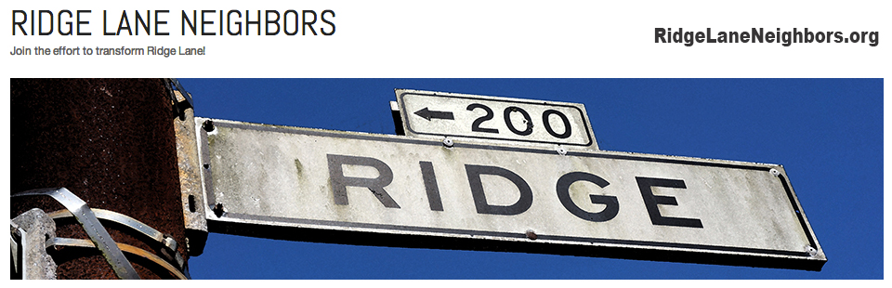

Join your neighbors working together with the SF Department of Public Works and Supervisor John Avalos in their effort to lobby the city to improve Ridge Lane.

Ideas up for consideration are steps for safe walking down to BART, plantings, lighting, and other improvements.

Find out more at:
RidgeLaneNeighbors.org

